Assignment no. 4
4)we have github repo in that index.html file present, also we have s3 bucket , in that enabled static website hosting, you need deploy index.html file in s3 bucket by using jenkins, hint by s3 cli cmd you will enable static website hosting.

Ans. We have installed Jenkins with below steps.
2nd menthod ---- here jenkin home directory is diffrent /root/.jenkins/
install java and tomcat deploy war file.
1)luanch ec2 instance -
yum list java-17-amazon*
2) install java ----- yum install java-17-amazon
3) create folder in /mnt ----- mkdir /mnt/servers
4) install tomcat 10 ---- wget https://dlcdn.apache.org/tomcat/tomcat-10/v10.1.53/bin/apache-tomcat-10.1.53.zip
5)unzip apache-tomcat-10.1.53.zip
6)rm -rf apache-tomcat-10.1.53.zip
7) chmod -R 777 apache-tomcat-10.1.53
8) cd apache-tomcat-10.1.53
9) cd webapps/
10)go to link and select latest Jenkins WAR file --- https://www.jenkins.io/doc/book/installing/war-file/
11)select past release option https://get.jenkins.io/war-stable/
12 select latest --> select jenkins.war file option.
13)wget https://get.jenkins.io/war-stable/latest/jenkins.war
14) cd ../
15) cd bin
16) ./startup.sh
17) cd ../
18) cd logs/
19) tail -100f catalina.out
Also installed HTTPD and Git
Provide git repo info and index file uRL,
Created 1 user to access AWS CLI
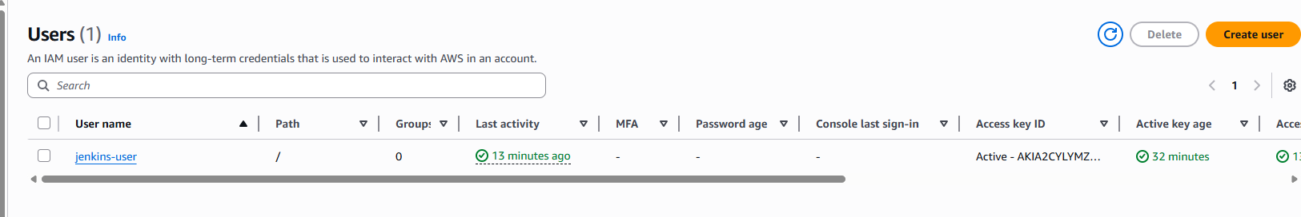
- Used below command to create bucket and grant permission
echo "===== START ====="

BUCKET_NAME=my-static-site-sandeep

echo "Checking bucket..."

if aws s3 ls | grep -q "$BUCKET_NAME"; then
echo "Bucket already exists"
else
echo "Bucket not found. Creating..."

aws s3 mb s3://$BUCKET_NAME

aws s3 website s3://$BUCKET_NAME --index-document index.html

aws s3api put-public-access-block \
--bucket $BUCKET_NAME \
--public-access-block-configuration \
BlockPublicAcls=false,IgnorePublicAcls=false,BlockPublicPolicy=false,RestrictPublicBuckets=false

aws s3api put-bucket-policy --bucket $BUCKET_NAME --policy "{
\"Version\":\"2012-10-17\",
\"Statement\":[{
\"Effect\":\"Allow\",
\"Principal\":\"*\",
\"Action\":\"s3:GetObject\",
\"Resource\":\"arn:aws:s3:::$BUCKET_NAME/*\"
}]
}"
fi

echo "Uploading files..."

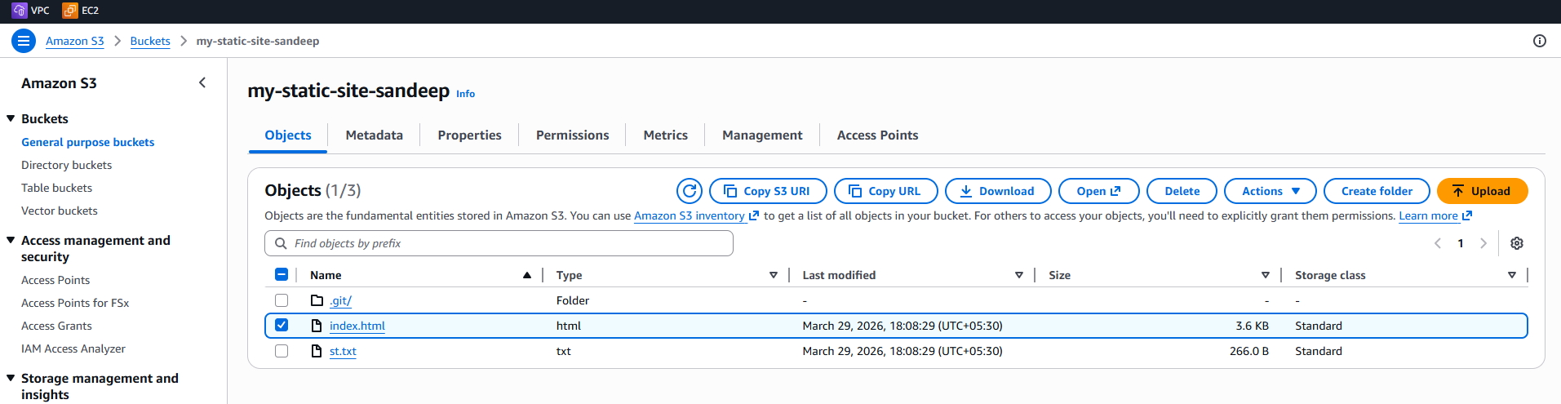

Output
